bit field in c language

bit fields are used to use memory efficiently yani agar bit field ka use na kare toh bhi hamara program banega but memory comparatively jayada use hogi , bit field hum structure or union ke sath karate hai

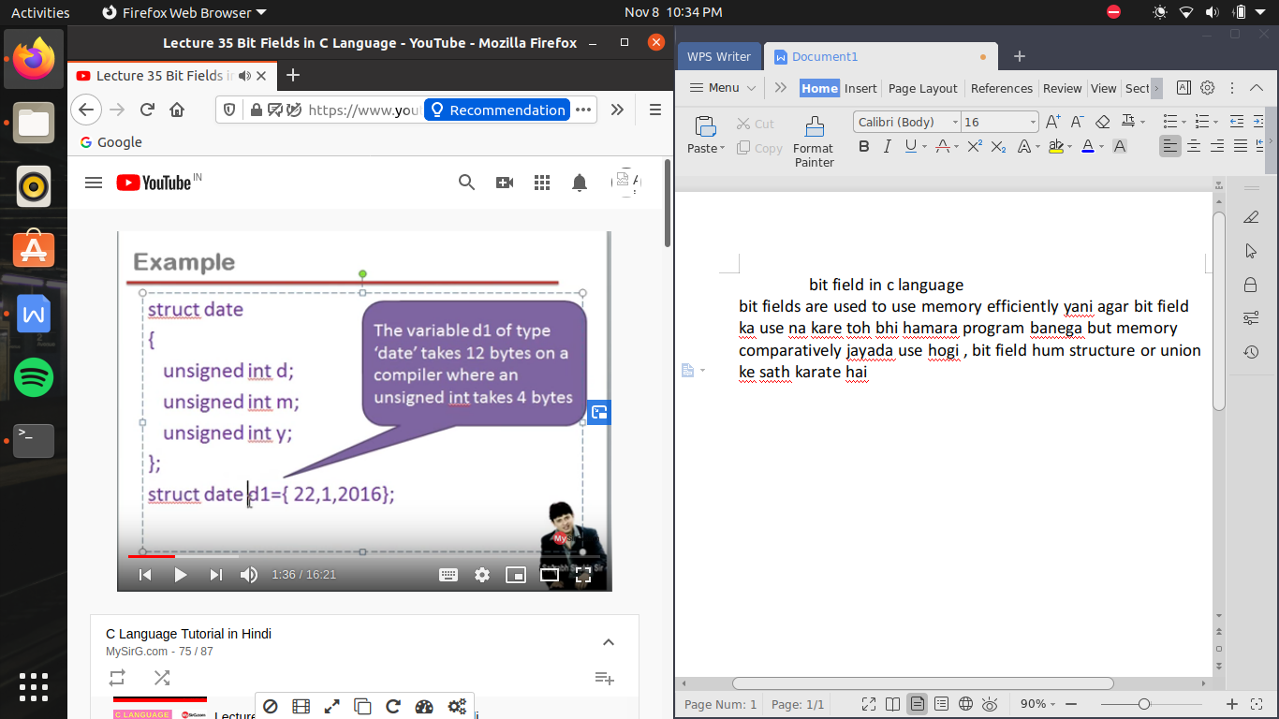

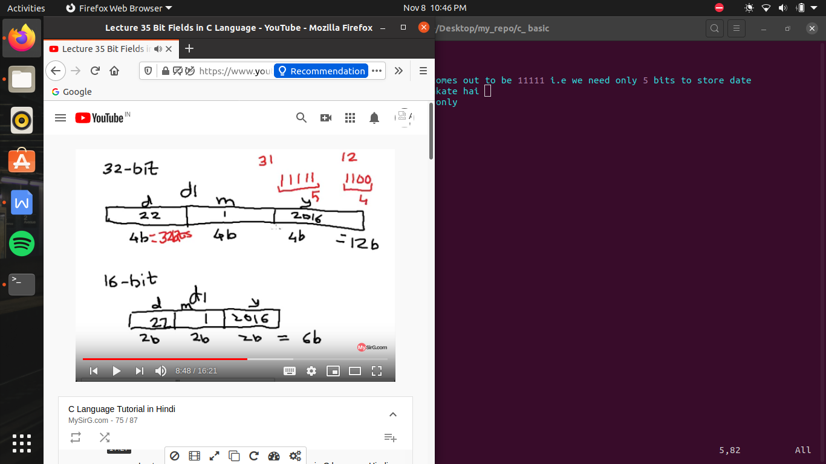

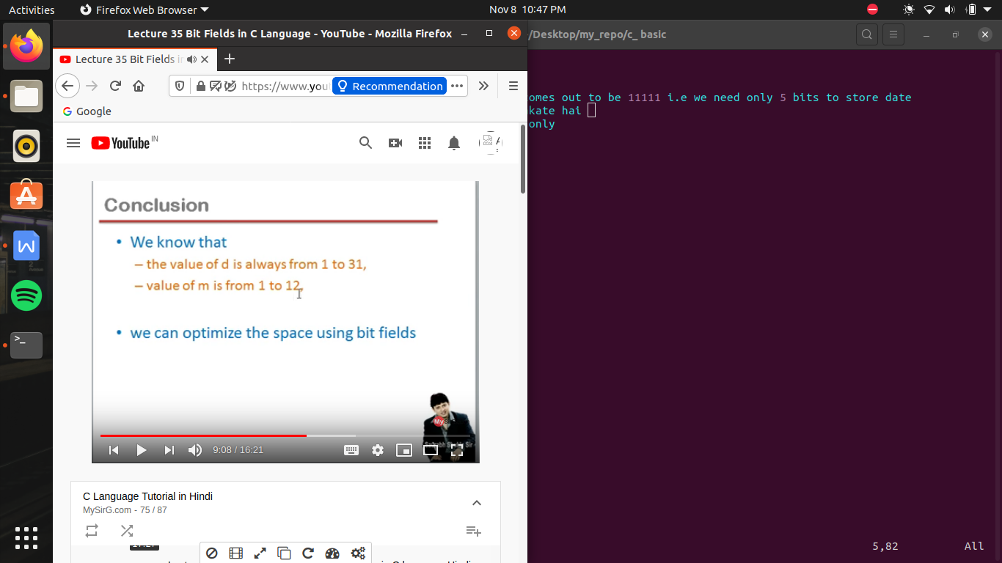

#include<stdio.h>

typedef struct date

{

unsigned int d:5; //here we write max calculated value i.e 31 having of 5 bits

unsigned int m:4;

unsigned int y; //we don't specify anything here because we can't specify any year which contain max binary bits

}DATE;

//now by using bit field memory be allocated by the block of 4-4 bytes only so here we don,t modify year so its take 4 bytes

//now a 4 bytes of block assign i.e 32 bits , now memory assign start of first 4 bits assign to date and next 5 bits assign to month

//now i.e 11 bits used , and remaning bits are remained empty as assignment of memory always be done on 4 bytes as we use int data type,i.e jab tak data 32 bits cross nhi karata hai tab tak use memory ese block me mil jayegi

//thus by data field now memory allocate in ram is 8 bytes , while before it was 12 bytes

/\*

typedef struct date

{

unsigned d; //as we know date never exceeds 31 and if do binary of 31 comes out to be 11111 i.e we need only 5 bits to store date

//but we gave here 4 bytes i.e 32 bits so yahi wastage ko hum kam kr sakate hai

unsigned m; // month never be more than 12 , binary is 1100 i.e 4 bits only

unsigned y;

}DATE;

\*/

void main()

{

DATE d1={8,11,2020};

printf("size of d1 = %d \n",sizeof(d1));

}

